**Batch: A2 Roll No.: 16010121045**

**Experiment / assignment / tutorial No. 3**

**Grade: AA / AB / BB / BC / CC / CD /DD**

**Signature of the Staff In-charge with date**

|  |
| --- |
| **TITLE:**  Menu driven program. |

**AIM:** Write a menu driven program for following option

a.To find whether a number is palindrome or not. (e.g. 1221 is palindrome)

b. To calculate the sum of the Fibonacci series up to ‘n’ terms(use do-while loop only)

c. To find the numbers and sum of all integer between 100 and 200 which are divisible by both 3 & 5.(use for loop only)

______**________________________________________________________________**

**Expected OUTCOME of Experiment:**

**CO2:** Applying basic concepts of C programming for problem solving.

**_____________________________________________________________________**

**Books/ Journals/ Websites referred:**

1. Programming in C, second edition, Pradeep Dey and Manas Ghosh, Oxford University Press.
2. Programming in ANSI C, fifth edition, E Balagurusamy, Tata McGraw Hill.
3. Introduction to programming and problem solving , G. Michael Schneider ,Wiley India edition.
4. [**http://cse.iitkgp.ac.in/~rkumar/pds-vlab/**](http://cse.iitkgp.ac.in/~rkumar/pds-vlab/)

**_____________________________________________________________________**

**Problem Definition:**

The program accepts a choice from the user using a switch case statement and generates output accordingly.

**Choice a**: The program checks whether a given numbered by user is palindrome or not.If a number remains same, even if we reverse its digits then the number is known as palindrome number. For example, 12321 is a palindrome number because it remains same if we reverse its digits.

**Choice b:** Sum of Fibonacci series up to n terms will be generated. Fibonacci series is a series in which each number is the sum of the last two preceding numbers. The first two terms of a Fibonacci series are 0 and 1.(use while loop only)

**Example:**

Input: n = 5

Output: 7

Explanation: 0 + 1 + 1 + 2 + 3 = 7

**Choice c:** To find the numbers and sum of all integer between 100 and 200 which are divisible by both 3 & 5.(use for loop only)

**Algorithm:**

1. Start
2. Declare n.
3. Ask the user to enter select a choice.
4. Read the value of n.
5. (Switch) check if n is.
6. Call **palin()**
7. Call **fibo()**
8. Call **sumnum()**

default. Ask the user to enter a correct option.

1. End.

**palin()**

1. Start
2. Declare n.
3. Ask user to input number to check for palindrome.
4. Read n.
5. Declare n1=n, ans=0 k=0.
6. **While** (n>0)
   1. k=n%10
   2. ans=ans*10+k
   3. n=n/10
7. if ans is equal to n1
8. **if true**, then print the number is palindrome.
9. **else**, the number is not palindrome.
10. End.

**fibo()**

1. Start
2. Declare n.
3. Ask user to enter the number of terms they want.
4. Read n.
5. **If** n equals to 1.
   1. Print 0.
6. **Else If** n equals to 2.
7. Print 0 1.
8. **Else If** n is greater than 2.
9. n=n-2
10. Declare a=0, b=1,k=0.
11. Print a followed by b on the same line.
12. **Do**
13. k=a+b.
14. a=b.
15. b=k.
16. print b
17. n=n-1.
18. **While** n>0
19. End.

**sumnum()**

1. Start.
2. Declare sum=0.
3. Print the numbers are:
4. **For** i=100 , **while** i<200, i=i+1
5. If i%3 is equal to 0 and i%5 is equal to 0.
6. Print i
7. Sum=sum + i
8. Print out sum.
9. End.

**Implementation details:**

#include <stdio.h>

void palin()

{

int n;

printf("Enter a num to check for Palindrome: ");

scanf("%d",&n);

int n1=n,k=0,ans=0;

while(n>0)

{

k=n%10;

ans=ans*10+k;

n=n/10;

}

if(ans==n1)

printf("The Number is a Palindrome");

else

printf("The Number is not a Palindrome");

}

void fibo()

{

int n=0;

printf("Enter the nth term for fibonacci series: ");

scanf("%d",&n);

if(n==1) printf("0");

else if(n==2) printf("0 1");

else if(n>2)

{

n-=2;

int a=0,b=1,k=0;

printf("%d %d",a,b);

do

{

k=a+b;

a=b;

b=k;

printf(" %d",b);

n--;

}

while (n>0);

}

}

void sumnum()

{

int sum=0;

printf("The Numbers are :\n");

for(int i=100;i<200;i++)

{

if(i%3==0 && i%5==0)

{

printf("%d ",i);

sum=sum+i;

}

}

printf("\nThe Sum is : %d",sum);

}

int main()

{

int n=0;

printf("1. Palindrome\n");

printf("2. Fibonacci\n");

printf("3. Find the numbers and sum of all int btw 100 and 200, div by 3 and 5\n");

scanf("%d",&n);

switch (n)

{

case 1:

palin();

break;

case 2:

fibo();

break;

case 3:

sumnum();

break;

default:

printf("Enter a correct option only");

break;

}

return 0;

}

**Output(s):**

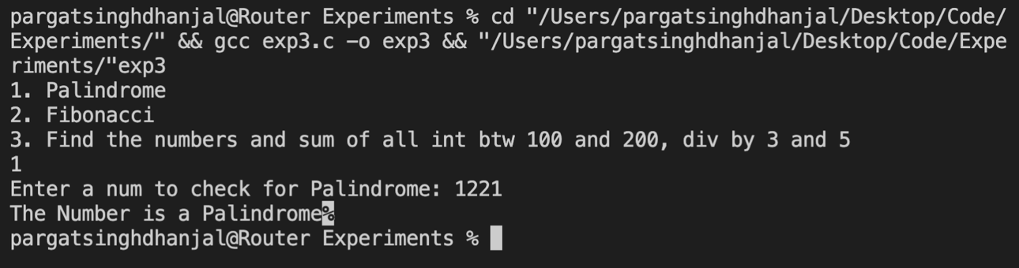

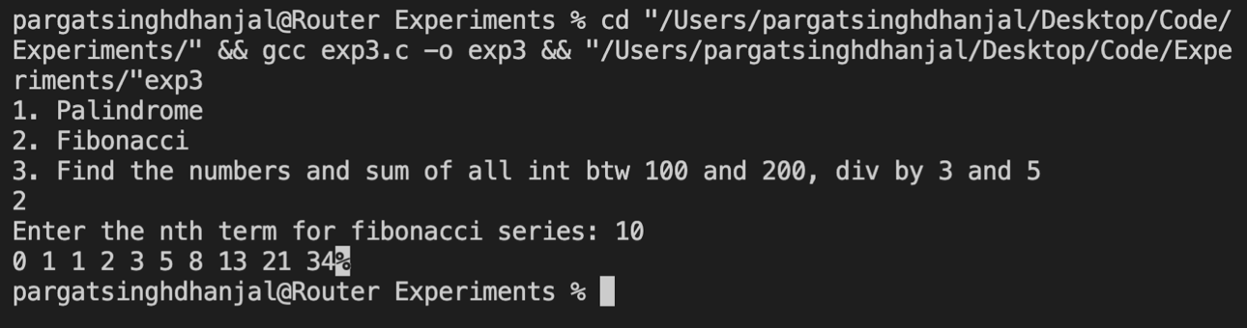

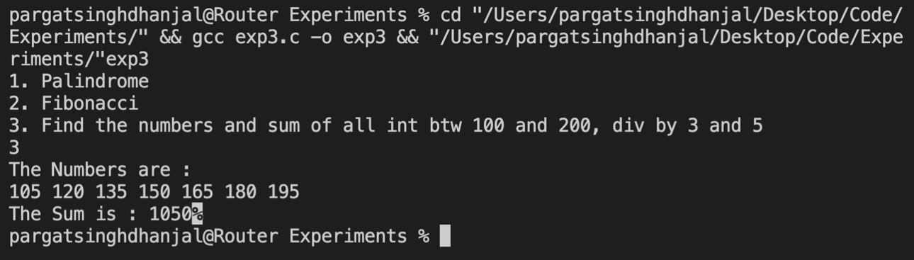

**Conclusion:**

Successfully executed Exp 3.

Learnt to use **Loops** i.e. *for loop, while loop* and *do while loop*. Also learnt to write menu driven programs using switch case.

**Post Lab Descriptive Questions**

**Write menu driven code for the following:**

The program allows a user to enter five numbers and then asks the user to select a choice from a menu. The menu should offer the following options –

1. Display the smallest number entered

2. Display the largest number entered

3. Display the sum of the five numbers entered

4. Display the average of the five numbers entered.

5. Exit

**Implementation**

#include<stdio.h>

double sum(double* arr)

{

double sum=0;

for(int i=0;i<5;i++)

sum+=arr[i];

return sum;

}

int main() {

double arr[5];

printf("Enter 5 numbers:\n");

for(int i=0;i<5;i++)

scanf("%lf",&arr[i]);

int n;

printf("\nSelect an option\n");

printf("1. Display the smallest number entered\n");

printf("2. Display the largest number entered\n");

printf("3. Display the sum of the five numbers entered\n");

printf("4. Display the average of the five numbers entered\n");

scanf("%d",&n);

double m=arr[0];

switch (n) {

case 1:

for(int i=1;i<5;i++)

if(m>arr[i])

m=arr[i];

printf("The smallest number is %.2lf\n",m);

break;

case 2:

for(int i=1;i<5;i++)

if(m<arr[i])

m=arr[i];

printf("The largest number is %.2lf\n",m);

break;

case 3:

m=sum(arr);

printf("The sum of all five numbers is %.2lf\n",m);

break;

case 4:

m=sum(arr)/5;

printf("The average of all five numbers is %.2lf\n",m);

break;

default:

printf("Enter a correct option only");

break;

}

return 0;

}

**Outputs**

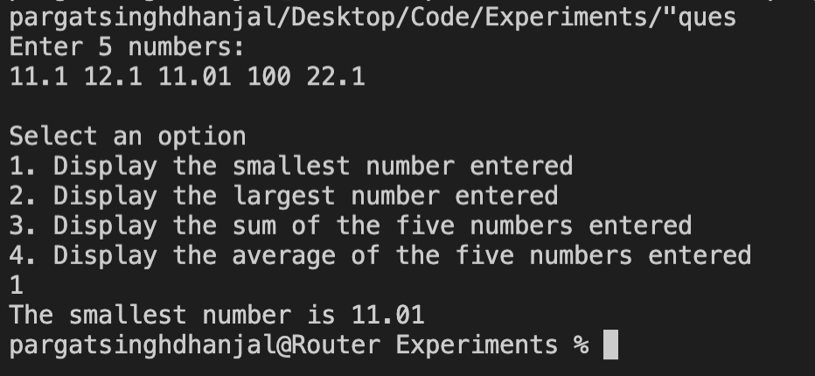

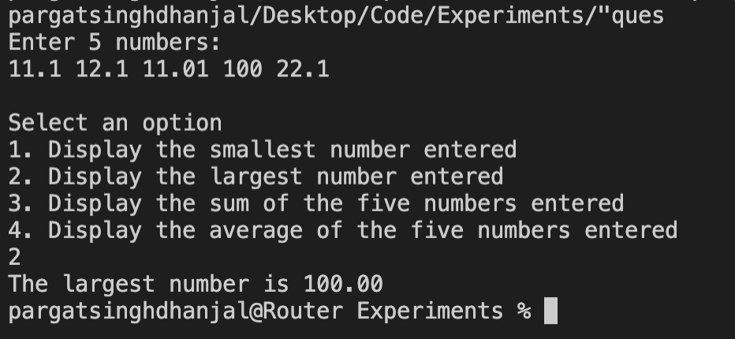

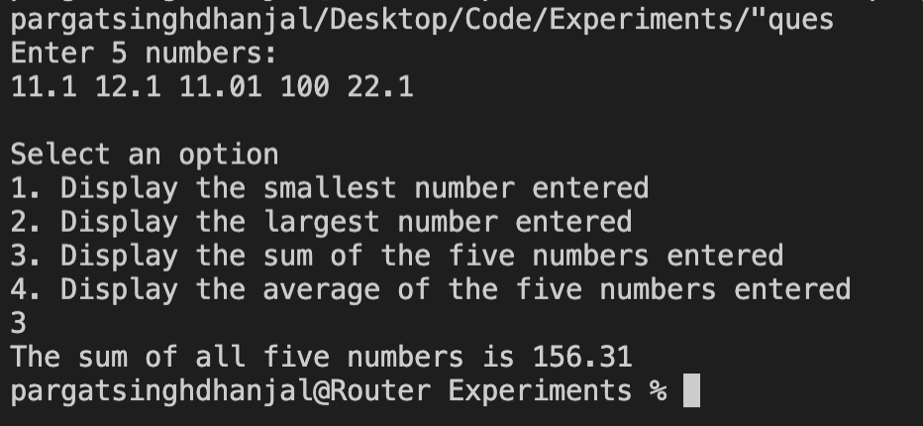

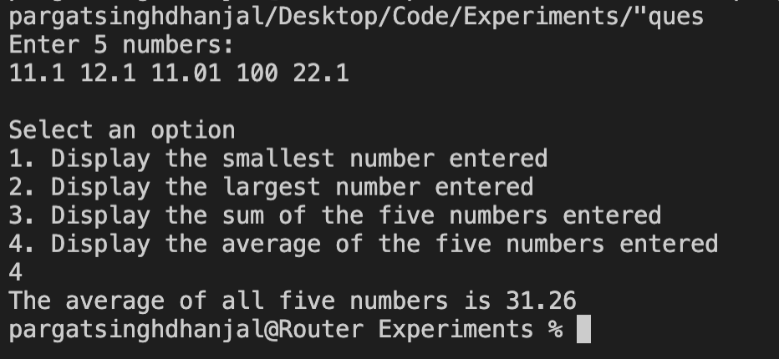

**Date: 25/11/2021 Signature of faculty in-charge**